First/Last example:

*/* Formatted on 7/30/2013 5:25:30 PM (QP5 v5.139.911.3011) */*

SELECT distinct event_dt, company_name,

decode(last_value(sum_income) over (partition by event_dt,company_name order by company_name)

- first_value(sum_income) over (partition by event_dt,company_name order by company_name),0,'one_record', (last_value(sum_income) over (partition by event_dt,company_name order by company_name)

- first_value(sum_income) over (partition by event_dt,company_name order by company_name))) dif_last_first

FROM u_dw_ext_references.agr_trans

order by 1

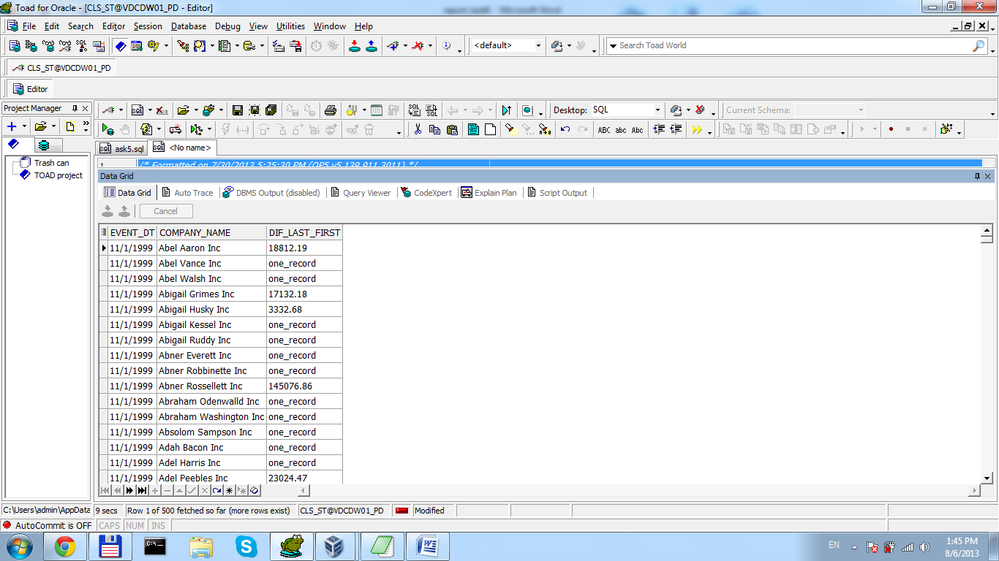

DENSE_RANK or RANK and LAG example

*/* Formatted on 8/6/2013 2:11:36 PM (QP5 v5.139.911.3011) */*

SELECT DISTINCT company_name companies_with_same_names

FROM (SELECT company_name

, cust_city

, RANK

, LAG ( RANK

, 1

, 0 )

OVER (ORDER BY company_name)

LAG

FROM ( SELECT DISTINCT company_name

, cust_city

, DENSE_RANK ( ) OVER (ORDER BY company_name) RANK

FROM u_dw_ext_references.agr_trans

ORDER BY 1))

WHERE RANK = LAG;

Dataset:

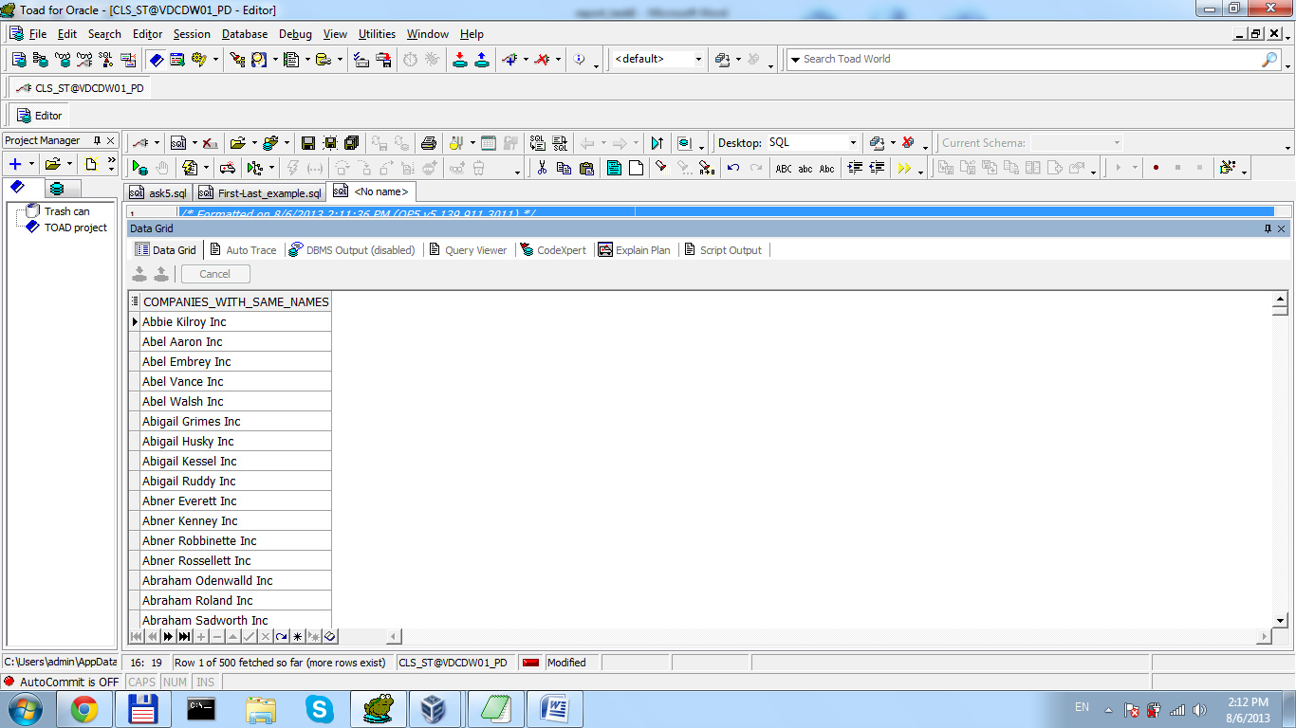

Min/Max/AVG examples

SELECT DISTINCT

event_dt

, company_name

, DECODE (

( MAX ( sum_income ) OVER (PARTITION BY event_dt, company_name)

+ MIN ( sum_income ) OVER (PARTITION BY event_dt, company_name) )

/ 2

, 0, 'single_record'

, ( MAX ( sum_income ) OVER (PARTITION BY event_dt, company_name)

+ MIN ( sum_income ) OVER (PARTITION BY event_dt, company_name) )

/ 2

)

diff_div_2

, AVG ( sum_income ) OVER (PARTITION BY event_dt) avg_moth

FROM u_dw_ext_references.agr_trans

ORDER BY 1

